Member Register - Application Form
SECTION 1. APR MEMBERSHIP

Membership Number __________________ Level of Membership _______________

SECTION 2. PERSONAL DETAILS

First Name _______________________ Last Name _______________________

Telephone _______________________ Mobile _______________________

Main Email _______________________ Secondary Email _______________________

Gender Male ☐ Female ☐ Date of Birth _______________________

Address __________________________________________________________________

__________________________________________________________________

Country _______________________ Post Code _______________________

SECTION 3. PROFESSIONAL DETAILS

Employment Status _______________________ Job Role ________________________

Company Name ________________________________________________________

Areas of Practice ________________________________________________________
SECTION 4. PPR TIER LEVEL

Which tier are you applying for? (Please see Tier Structure definitions)

Tier 1 ☐ Tier 2 ☐ Tier 3 ☐ Tier 4 ☐

SECTION 5. PUBLIC REGISTER

Your name will be included on the public register, however please complete any additional information you require on your profile.

Company Name ________________________ Telephone ___________________________

Email ___________________________

Address __________________________________________________________________

__________________________________________________________________

Country _______________________ Post Code _______________________

SECTION 6. BECOME A PROFESSIONAL PARALEGAL PRACTITIONER

Will you also be applying for a Practising Certificate?

Yes ☐ No ☐

If yes, then please contact us for the Practising Certificate Application Form. Please note you will be required to provide evidence of PII, suitability and the appropriate fee.

Only members who have paid for membership of the PPR can apply for a PCC.

SECTION 7. PAYMENT

The annual cost of membership is £25 for all Tiers. There is an additional fee of £12 for certificates to be sent by post outside of the United Kingdom.

Payment methods Bank transfer ☐ Credit/debit card by phone ☐

Bank : Santander
Account Name : The Professional Paralegal Register
Account : 38801343
Sort Code : 09-01-29

SECTION 8. DECLARATION

I declare that the information given in this form is correct. I understand that once I am registered on the PPR, I agree to be bound by the Practitioners Rules and decisions of the Register Regulatory Committee and all other regulations of the PPR for the time being in force including the Code of Conduct.

Signed: _______________________ Dated: Click or tap to enter a date.

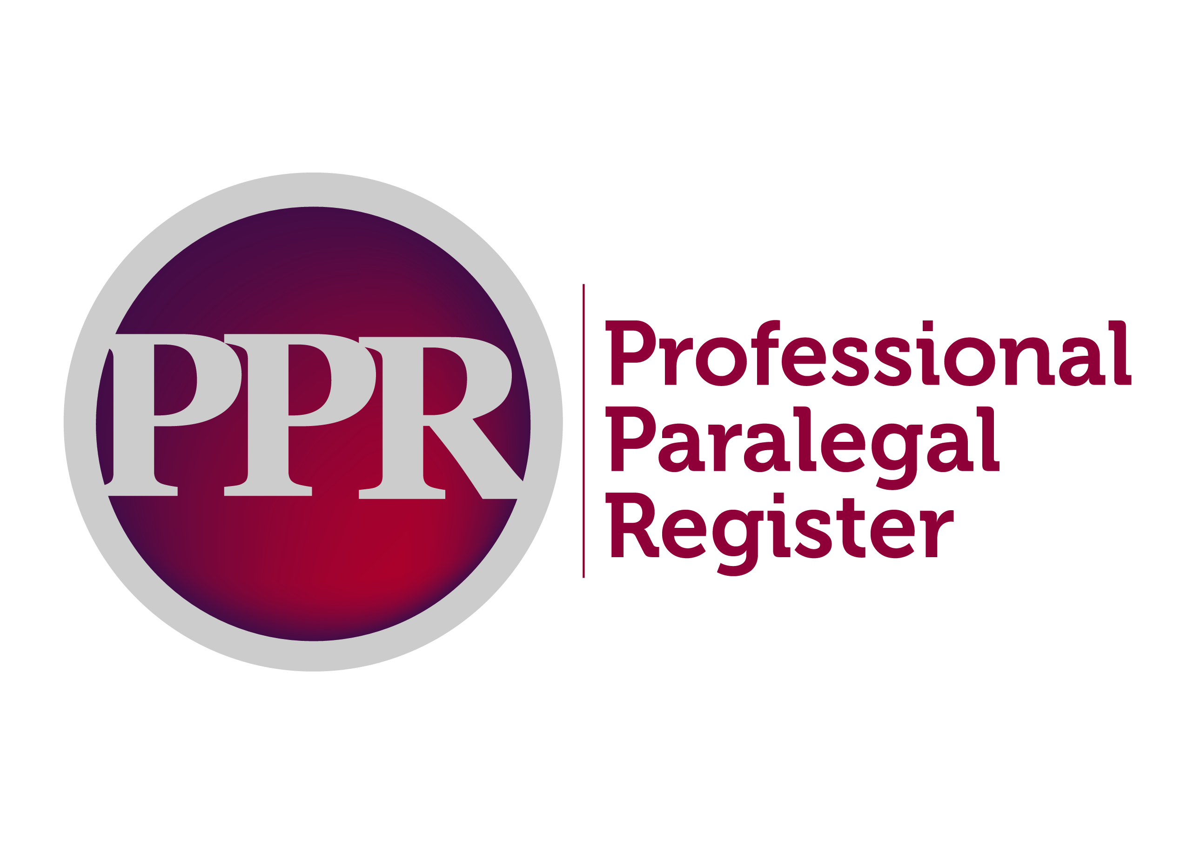

PPR Tiers Explained
Categories
For the purposes of voluntary regulation under the PPR, whether you are an Associate, Member, or Fellow with your membership body, under the PPR you will be recognised by your knowledge and experience as a ‘Tier’.
For end users whether they are companies, local authorities, consumers, solicitor’s or barristers, a simple Tier structure will make it easy for professional paralegals to be recognised.
If you are unsure which category you should apply for, you should talk to your recognised membership body.
You MUST be a member of a recognised membership body to enable you to gain entry onto the PPR.
A Tier 1 Paralegal
- Typically you will be a trainee Paralegal who is studying to achieve a level 3 qualification (equivalent to A Level) and has no or very little work experience.
- A Tier 1 may be engaged in legal secretarial work; legal administration or general legal office assistance.
A Tier 2 Paralegal
You will be a Paralegal who has either obtained a level 3 qualification and/or has a minimum of two years ‘qualifying’ experience.
- A Paralegal in Tier 2 may have many years of experience in a particular area of practice.
- Tier 2 Paralegals may also be law graduates that have no or very little relevant work experience.
- A Tier 2 Paralegal may be offering services to the general public (subject to obtaining a Paralegal Practising Certificate); assist in many legal matters; prepare cases and assist litigants in person amongst many other things.
- Your area of knowledge, experience and expertise will determine the nature of the service or services that you may offer under a Paralegal Practising Certificate.
A Tier 3 Paralegal
- You are a Paralegal that has gained a minimum of a Level 6 qualification (Degree Level) AND has a minimum of 2 years qualifying experience.
- Typically a Tier 3 Paralegal is a graduate in law or has an equivalent professional qualification in the area of law in which they practice.
- A Tier 3 will typically be fee earners as Paralegals and can carry out complex legal matters.
A Tier 4 Paralegal
- Typically a Tier 4 Paralegal will have a Level 6 or above qualification, a minimum of 4 years qualifying experience and have undertaken Paralegal Practice Skills or Practice skills within their chosen field.
- These Paralegals are likely to be Fellows of their membership body and have expertise in one or more areas of law gained over many years.
What is a Professional Paralegal Practitioner?
A Professional Paralegal Practitioner is a paralegal who is regulated by the PPR and holds a current Professional Paralegal Practising Certificate (PPC).
You must be at least a Tier 2 to apply for a PPC and hold the requisite minimum of £1 million PII.
The PPC may be a ‘Specified’ certificate that enables one area of law to be practised, OR a ‘Full’ Certificate for Tier 4’s if a range of areas of law/services are being offered.
A PPC is only required where legal services are being offered to the general public.
The PPR may impose conditions on PPC’s and can withdraw them if a serious breach of the Paralegal Practitioners Rules or the Code of Conduct occurs.

